[**Quick 48hours! Topcoder - Update Logic For Challenge Fees Managment v1.0**](https://apps.topcoder.com/forums/?module=Category&categoryID=41481)

**Verification Guide**

# 

# Setup

The setup process remains the same as the previous challenge.

Please check the README.md for how to setup and start the billing account services.

For informix database, create the sql:

delete from tcs_catalog:id_sequences where name in ('project_contest_fee_seq', 'project_contest_fee_percentage_seq');

insert into tcs_catalog:id_sequences values('project_contest_fee_seq', 5000, 1, 0);

insert into tcs_catalog:id_sequences values('project_contest_fee_percentage_seq', 5000, 1, 0);

delete from time_oltp:project_contest_fee_percentage;

delete from time_oltp:project_contest_fee;

Import billing-accounts_clients-env.postman_environment.json and billing-accounts-and-clients.postman_collection.json. Select the billing-accounts_clients-env environment.

# Verify

Check the sub folder challenge-fees, and apis for test are in this sub folder.

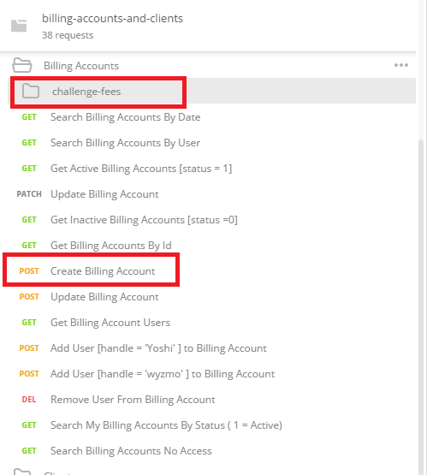

Please check 'Create Billing Account' to create two billing accounts for tests, assume that you have two billing account ids created: 80000020 and 80000021

Create challenge fees challengeFixed=true

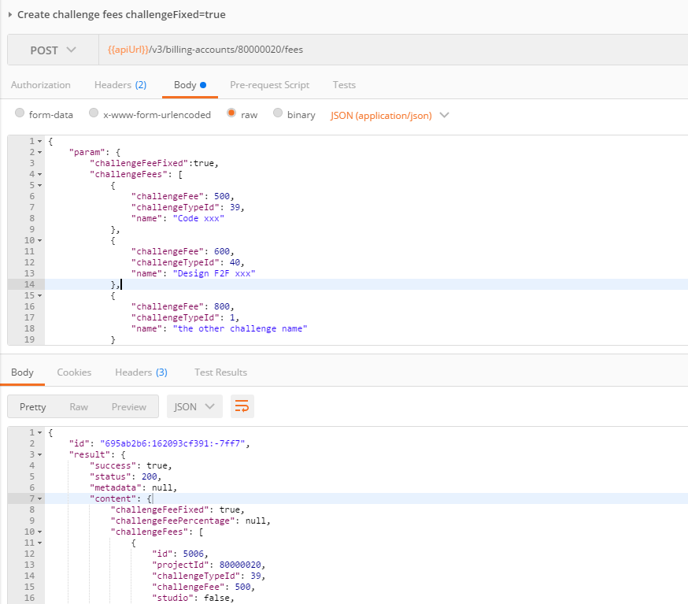

Check the database:

select * from time_oltp:project_contest_fee where project_id=80000020;



select * from time_oltp:project_contest_fee_percentage where project_id=80000020;



Create challenge fees challengeFixed=false

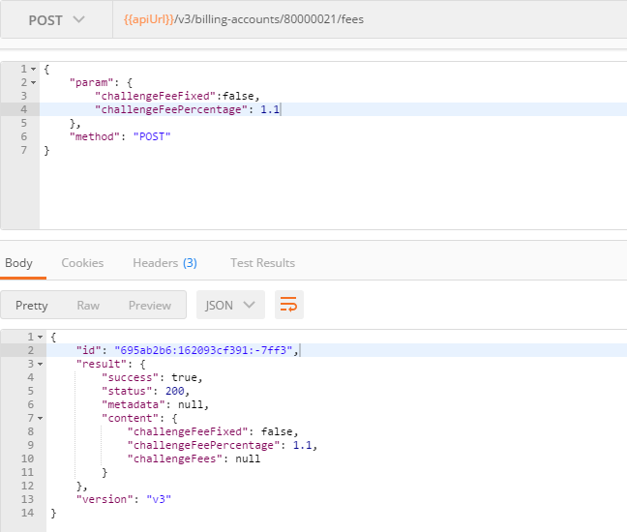

select * from time_oltp:project_contest_fee where project_id=80000021;



select * from time_oltp:project_contest_fee_percentage where project_id=80000021;



Update challenge fees:

The challenge fees ids(5006 and 5007) in the request body are the ones returned from the create operations.

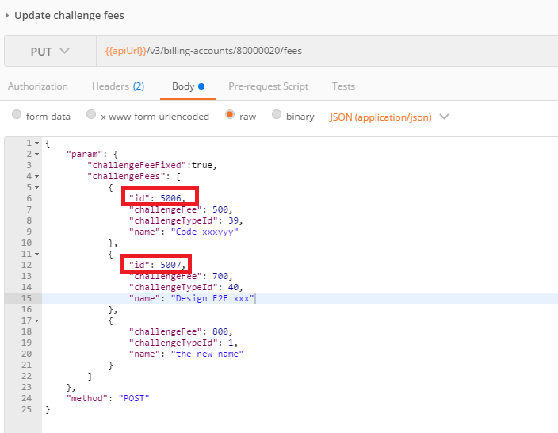

The response should show that the challenge fee with id 5006 and 5007 are updated, and the id with 5008 should be removed.

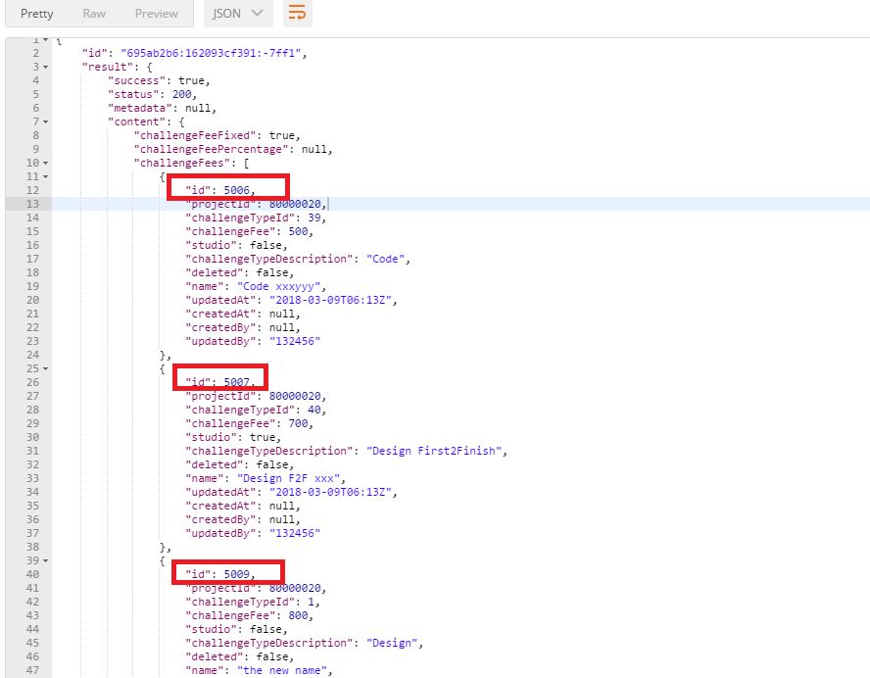

Check the database:

select * from time_oltp:project_contest_fee where project_id=80000020;



select * from time_oltp:project_contest_fee_percentage where project_id=80000020;



Update challenge fees (change fixed fee)

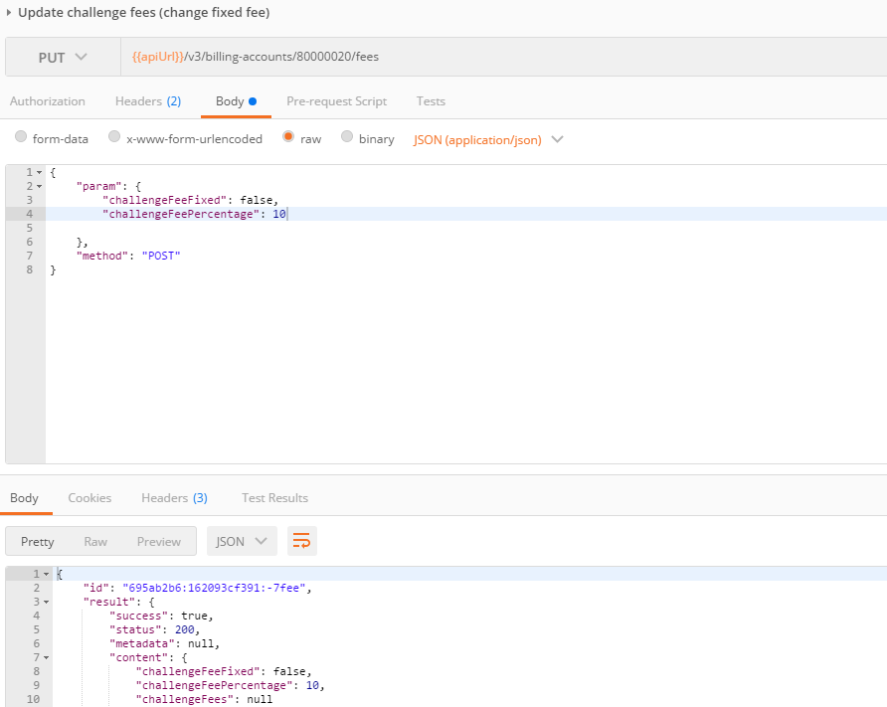

Check the database:

select * from time_oltp:project_contest_fee where project_id=80000020;



select * from time_oltp:project_contest_fee_percentage where project_id=80000020;



Get challenge fees  
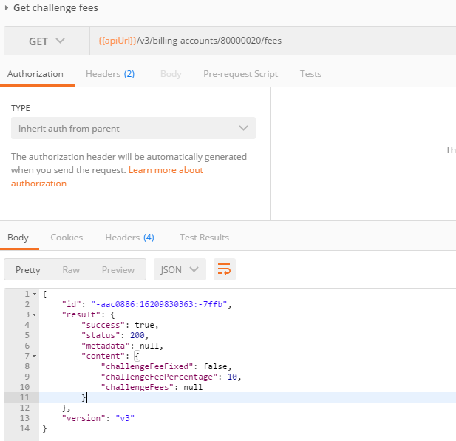

For other apis, please check them in the same way.